Welcome to Year 4

Teaching in Year 4, we are lucky to have Mr Anderton who is the teacher in 4A and Mrs Thaklar who is teaching in 4T. We also have Mrs Caroll supporting across the year group from Monday—Wednesday and Mrs Blizzard from Wednesday—Friday.

In Year 4, this half term we shall be covering...

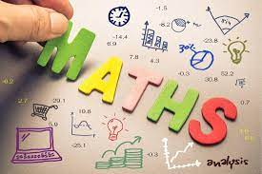 | In Maths, this half term we’ll be covering:  Area—we will explore the following questions and concepts: What is area? Counting in squares to find area, making shapes and comparing area.  We will spend a number of weeks focusing on fractions. We will discover the difference between unit and non-unit fractions. Count in tenths, explore a range of equivalent fraction, explore fractions greater than one and add 2 or more fractions.  In addition, we will be regularly practising our times tables in preparation for our times tables check in June. Maths homework will primarily revolve around this. To support your child in doing well in the check, please practise the times tables whenever possible. One strategy we use to learn times tables are our ‘rolling number’ songs. These songs can be found in the ‘Year 4 Homework’ class on Showbie.
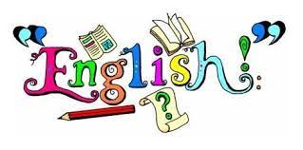 | This half term in English, we’ll be exploring a number of texts types including narratives and non-fiction—focusing on writing to entertain and inform.  Within these texts types, we’ll be learning a range of grammatical devices including fronted adverbials, using a range of conjunctions, nouns and pronouns and possessive apostrophes for plural nouns.  In Shared Reading, will we continue to explore a range of reading skills such as; inference, retrieval, understating the meaning of words in context, prediction and summarising. We are continuing to read the book ‘Wizards of Once’, which the children are thoroughly enjoying.  Spelling will be taught weekly with tests taking place each Wednesday. We also have a ‘mini test’ the following Monday—practising 3 of the words the year group struggled with the most.  Some children will continue on their Read Write Inc programme with daily sounds shared separately.
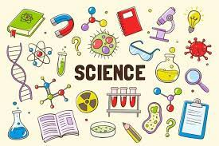 | This half term, in Science we’ll be exploring the topic of Electricity.  Within this topic, we shall be learning about how electricity has impacted our daily lives and routines, what the impact of a switch has in a series circuit and what the difference is between insulators and conductors. We will also be developing our scientific skills through practical activities and investigations.
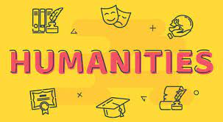 | This half term, we are studying geography.  Within this area of study, our children will learn about global trade. We will look at how trade became global and explore key terms such as: trade, globalisation and scale.  We will discover how trade has advanced through different time periods, including: The Stone Age, the 17th Century and the 21st Century.  Following this, we will look at the difference between importing and exporting and how the food in our supermarkets reaches the shelves.
 | This term in Music, we’ll continue our whole class instrumental tuition in Dhol Drums and Steel pans. We will continue building our performance skills and repertoire. We are hoping to share more performances with other classes across school.
 | Our art lessons this half term will be with our Art specialist Mrs Shellam. The children will be focussing on their drawing skills and show some areas of light and shadow in their drawings. We will also explore how we can layer colours and materials to create different effects.
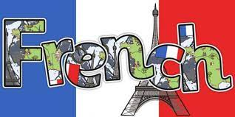 | In French, we are continuing our theme of ‘All about me’. We have been looking at personality descriptions and will now move on to describe our clothes.  We will look at clothes we like wearing and will discuss our school uniform.  We will also learn about colours and the new grammatical rule of how in French, the colour comes after the noun.
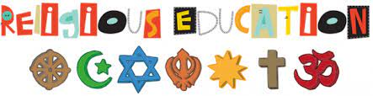 | This term in RE, year 4 will explore the process of gaining knowledge. We will use questions as keys to acquire knowledge to express our curiously about the world we live in and the universe.
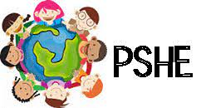 | This term in PHSE, year 4 will explore the rights of the children as outlined by the United Nation’s convention.  We will discuss and build our knowledge around the responsibilities that comes with those rights and how we can support others.
This half term, we’ll be exploring the programming system Scratch.

This unit explores the concept of repetition in programming using the Scratch environment. It beings with a Scratch activity similar to that carried out in previous units, where learners can discover similarities between two environments.

Learners will look at the difference between count-controlled and infinite loops, and use their knowledge to modify existing animations and games using repetition.

Children’s final project is to design and create a game which uses repetition, applying stages of programming design throughout.
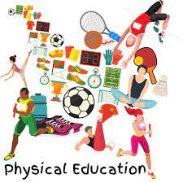 | In PE, our focus will be on dance with Ms Gray. The children will choreograph and perform their own dance routine focussed around a specific theme.

